- All
- People
- Nature
- Drone
- Industrial
- Indigenous
- Other


Nature  Drone  Indigenous | Nature  Drone  Indigenous | People  Indigenous | Nature  Drone  Indigenous | Nature  Indigenous
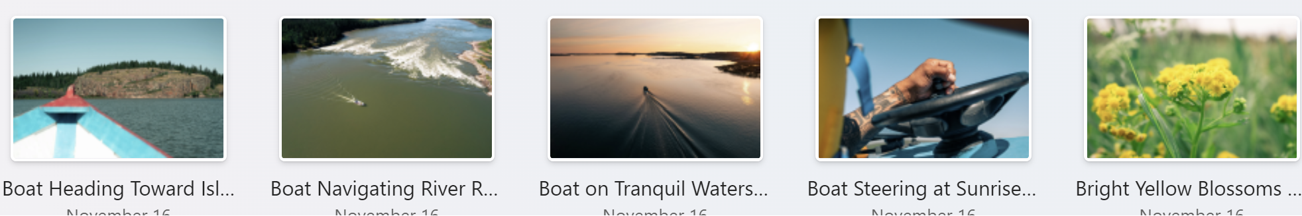
Nature  Indigenous | Nature  Drone  Indigenous | Nature  Drone  Indigenous | Other  Indigenous | Nature  Indigenous

People  Indigenous | People  Indigenous | Nature  Indigenous | Nature  Drone  Indigenous | People  Indigenous
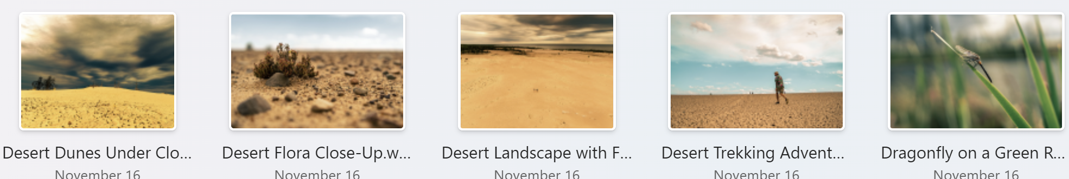
Nature  Indigenous | Nature  Indigenous | Nature  Drone  Indigenous | People  Nature  Indigenous | Nature  Indigenous
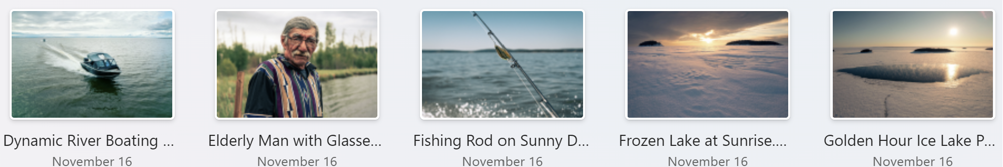
Drone  Nature  Indigenous  Other | People  Indigenous | Nature  Other  Indigenous | Nature  Drone  Indigenous | Nature  Drone  Indigenous
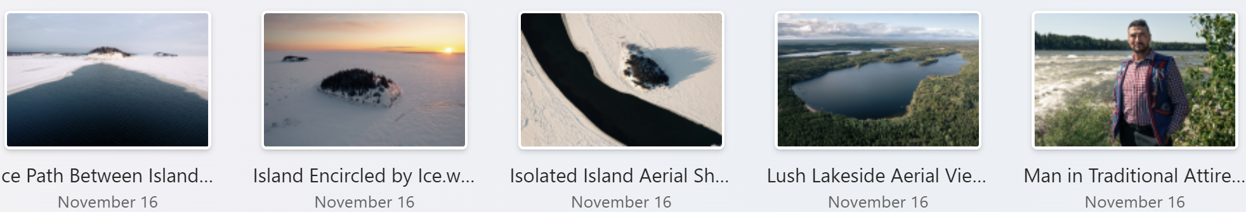
Nature  Drone  Indigenous | Nature  Drone  Indigenous | Nature  Drone  Indigenous | Nature  Drone  Indigenous | People  Indigenous
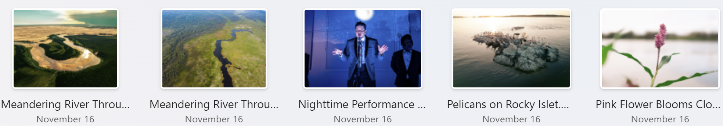
Nature  Drone  Indigenous | Nature  Drone  Indigenous | People  Indigenous | Nature  Drone  Indigenous | Nature  Indigenous

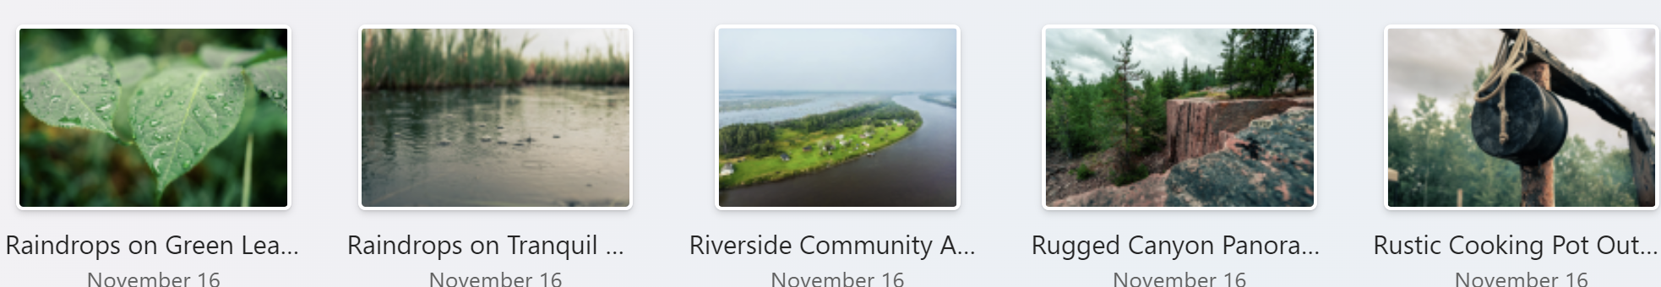
Nature  Indigenous | Nature  Indigenous | Nature  Drone  Indigenous | Nature  Drone  Indigenous | Other  indigenous
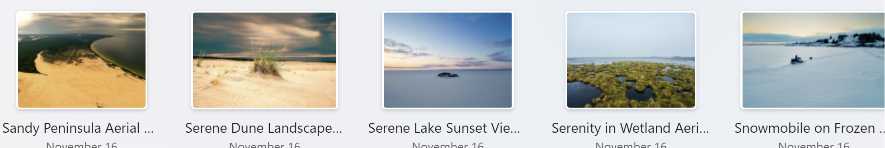
Nature  Drone  Indigenous | Nature  Indigenous | Nature  Drone  Indigenous | Nature  Drone  Indigenous | Nature  Drone  Indigenous
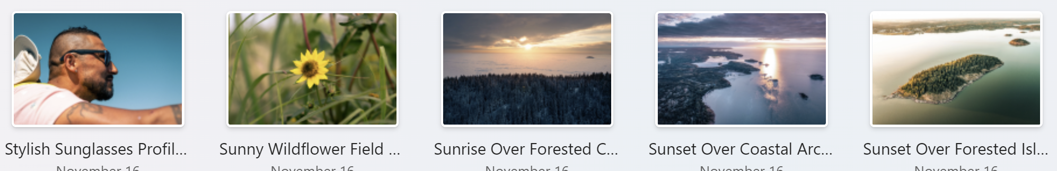
People  Indigenous | Nature  Indigenous | Nature  Drone  Indigenous | Nature  Drone  Indigenous | Nature  Drone  Indigenous
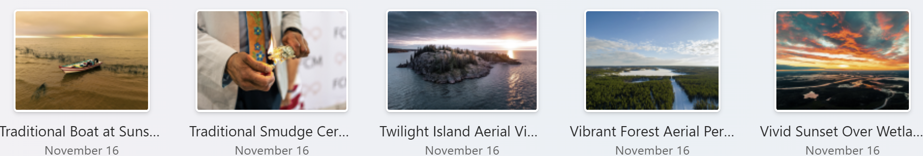
Nature  Drone  Indigenous | People  Other  Indigenous | Nature  Drone  Indigenous | Nature  Drone  Indigenous | Nature  Drone  Indigenous

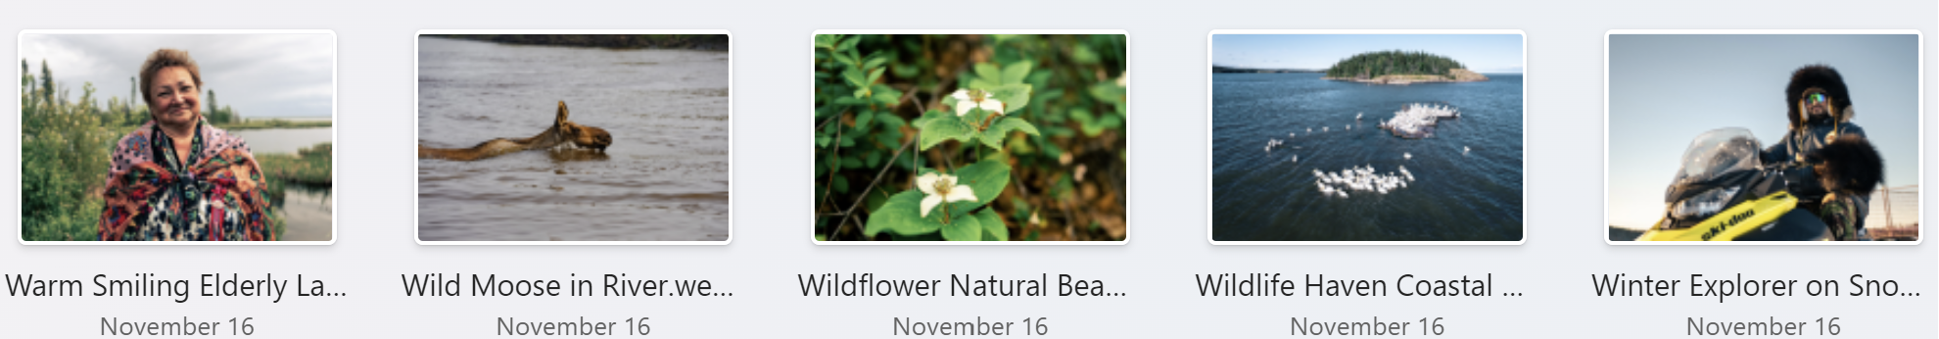
People  Indigenous | Nature  Indigenous | Nature  Indigenous | Nature  Drone  Indigenous | People  Indigenous

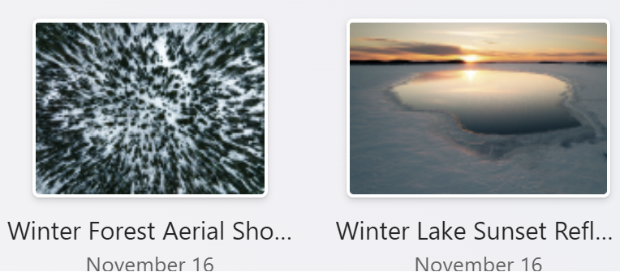
Nature  Drone  Indigenous | Nature  Drone  Indigenous

